**Quiz Answers**

# Question 1

Saturated means a molecule contains a C-C bond - True

Haemoglobin is a fibrous protein - False

Guanine pairs with thymine - True

Enzymes increase activation energy - False

Temperature increases kinetic energy in enzymes - True

Cyanide is a reversible inhibitor - False

Enzymes are substrate specific - True

Prokaryotic cells contain ribosomes - True

For a Transmission Electron Microscope a specimen has to be alive - False

Chloroplasts contain DNA - False

Mitochondria contain ribosomes - True

A solution always has a negative water potential - True

Water potential is measured in pascals - False

The hypertonic solution is weaker - False

In a hypotonic solution animal cells become crenated - False

Fluorouracil inhibits microtubules - False

Humans are described as diploid - True

Prophase is the first stage of mitosis - True

Meiosis produces haploid cells – True

# Question 2

If water potential of the bucket is -350, choose the cell of Ψs -539 and Ψp 150

If water potential of the bucket is -478, choose the cell of Ψs -572 and Ψp 71

If water potential of the bucket is -219, choose the cell of Ψs -344 and Ψp 45

If water potential of the bucket is -798, choose the cell of Ψs -852 and Ψp 32

If water potential of the bucket is -576, choose the cell of Ψs -681 and Ψp 92

If water potential of the bucket is -856, choose the cell of Ψs -898 and Ψp 24

If water potential of the bucket is -907, choose the cell of Ψs -956 and Ψp 11

If water potential of the bucket is -634, choose the cell of Ψs -915 and Ψp 240

If water potential of the bucket is -176, choose the cell of Ψs -289 and Ψp 95

# Question 3

**Eukaryotic Cells Prokaryotic Cells**

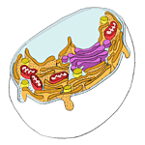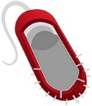

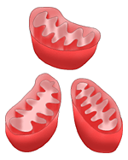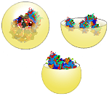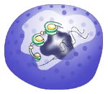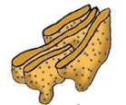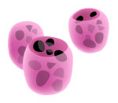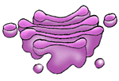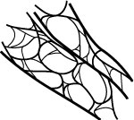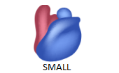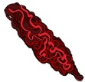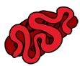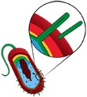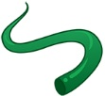

# Question 4

**Animal Cells Contain:**

Nucleus, Mitochondria, Cell Membrane, Cytoplasm, Golgi Apparatus, ER, Ribosomes, Lysosomes, Centrioles

**Plant Cells Contain:**

Nucleus, Mitochondria, Cell Membrane, Cytoplasm, Golgi Apparatus, ER, Ribosomes, Cell Wall, Chloroplast, Vacoule

**Fungal Cells Contain:**

Nucleus, Mitochondria, Cell Membrane, Cytoplasm, Golgi Apparatus, ER, Ribosomes, Lysosomes, Centrioles, Chitin Cell Wall, Vacoule

# Question 5

**Question 1**

In which stage of mitosis does the centrioles migrate to opposite poles? - Prophase

In which stage of mitosis does the nuclear membrane start to break down? - Prophase

In which stage of mitosis does the chromosones align along equator? - Metaphase

In which stage of mitosis does the contracting microtubules pull chromatids apart? - Anaphase

In which stage of mitosis does the nuclear membrane start to reform? - Telophase

**Question 2**

The __________ for a small number of genes may differ in the two chromosones - Alleles

A __________ shows the chromosones arranged in homologous pairs - Karyotype

DNA coils tightly around histone to form a structure called a __________ - Nucleosome

Humans are described as being __________ - Diploid

Chromosones consist of an extended DNA molecule supportd by special proteins called __________ - Histone

**Question 3**

In which stage of the cell cycle do organelles replicate or form? - G1

In which stage of the cell cycle is DNA duplicated and chromatids form? - S

In which stage of the cell cycle are spindle proteins synthesised? - G2

In which stage of the cell cycle does the cell replicate? - Mitosis

In which stage of the cell cycle does the cell split? - Cytokinesis